Ignite Visibility Consulting
YouTube

Contents
Introduction 3
Your Page 3
Branded URL 3
Background and Profile Picture 3
Fill out all Text 3
Videos 4
Theme your Videos Around One Keyword 4
Add a Date, Describe a Location, Link to Social Sites and Links to YouTube Video 5
Get Video Embeds, +1s, Ratings, Views and Comments Gradually 5
Add Annotations to Videos 5
Make Videos a Digestible Length 6
Other Tips to Consider 6

Introduction
By optimizing YouTube videos a specific way, we can gain more views. In this document we outline the Ignite Visibility YouTube optimization process.

Your Page
In this section we will cover setting up and configuring your page.

Branded URL
When selecting your username, make sure to use your business name. By doing this, you will be able to get a branded URL: www.youtube.com/user/IgniteVisibility
Here we see our URL is Ignite Visibility.

Background and Profile Picture
Your YouTube background should be 2000x1500. Your profile picture should be a square images which renders at 98 X 98 px.
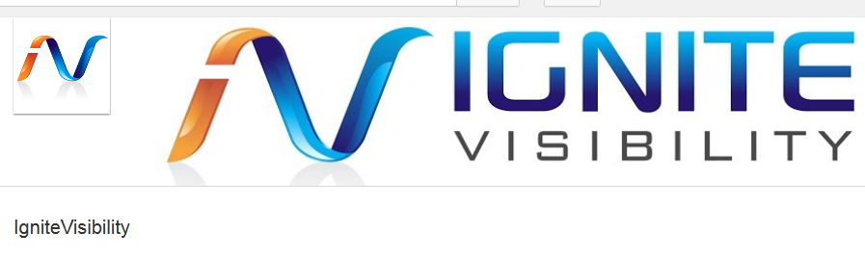

Fill out all Text
Make sure to take a moment and fill out all the text in the about section. This will allow the page to rank better in search. It is also recommended to add links to your other social media profiles in the about section, so that people know where to connect with you on other social media websites.

Videos
There are a few things to keep in mind when uploading videos to maximize exposure.

Theme your Videos Around One Keyword
It is critical to choose one keyword that best describes the video and work that keyword into the title, description and tags.
For example, this post is optimized for Hummingbird Update SEO.
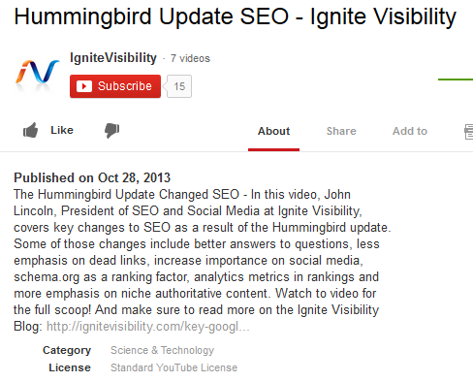
We also see hummingbird update in the description.
Here we see hummingbird update SEO in the title.
It is critical to use keywords in the title, the description and in the tags. It is recommended to have 3 to 10 tags per video. Each tag should precisely revolve around the theme of the video. For example.
- Tag 1: Hummingbird Update SEO
- Tag 2: Hummingbird Update
- Tag 3: Google Hummingbird Update
- Tag 4: Google Hummingbird Update SEO
Make sure to use your keyword in:
- The video file name
- The video title
- The video description
- The video tags
- The video annotations

Add a Date, Describe a Location, Link to Social Sites and Links to YouTube Video
By adding a date inside the text of the video, as well as mentioning a location the video was taken, it can help it rank in the search space. These details help the YouTube search engine surface correct videos.
Furthermore, make sure to add links to your video description to your social media sites and areas on your website which cover the topic.
- Add a data
- Add a location
- Link to your social media sites
- Add a link to the actual YouTube video
- Add a link to pages that cover this topic on your website

Get Video Embeds, +1s, Ratings, Views and Comments Gradually
Once the video is released, its success will depend on how users interact with the video. This is why it is always a great idea to promote your video by doing things like:
- Sending it out in an email newsletter
- Blogging about your video and embedding the video in your blog post
- Sharing your video on social media
- Advertising your video on YouTube
- Sharing your video with bloggers and news sites in your industry
By getting embeds, +1s, good ratings, views and comments overtime, your video will remain at the top of the search engines and continue to get exposure. These are the main signals that YouTube looks at. If YouTube does not see these signals, the video will go dead.

Add Annotations to Videos
An annotation is a text box which you can place text in. Here is an example.
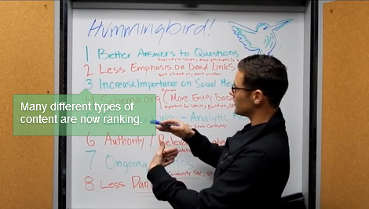
This green box is an example annotation.

To add an annotation, simply click on the box.
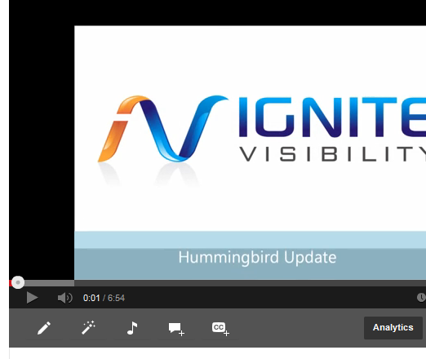
Here we see the annotation box.

Texts in annotations help videos get indexed. In addition, you can link to other YouTube videos in annotations and even use them for calls to action, such as, subscribe to our channel!

Make Videos a Digestible Length
While YouTube videos can be any length, remember that people have very short attention spans. Try to keep your videos brief, usually in in the 2 to 4 minute range.

Other Tips to Consider

- The first 24 to 48 hours is very important. The more interaction the better.
- Make sure to embed your video on a blog and share it as much as possible.
- Consider doing a press release and linking back to the blog post.
- Consider uploading your YouTube video to other video sites like Geyser, Hay!Spread, TubeMogul, VideoWildFire.
- Make sure to subscribe to other peoples channels and comment on others videos to get noticed.

